*&---------------------------------------------------------------------*  
*& Report  ZYNY_TEST2  
*&  
*&---------------------------------------------------------------------*  
*&  
*&  
*&---------------------------------------------------------------------*  
REPORT ZYNY_TEST2.  
  
TYPES : BEGIN OF ty_spfli,  "User defined internal table type  
          carrid    TYPE spfli-carrid,  
          connid    TYPE spfli-connid,  
          countryfr TYPE spfli-countryfr,  
          cityfrom  TYPE spfli-cityfrom,  
        END OF ty_spfli.  
  
DATA : it_spfli TYPE TABLE OF ty_spfli, "SPFLI internal table  
       wa_spfli TYPE ty_spfli. "work area  
  
DATA : t_fcat_spfli TYPE slis_t_fieldcat_alv. "field catalog for SPFLI table  
DATA : w_fcat_spfli LIKE LINE OF t_fcat_spfli.  
  
TYPES : BEGIN OF ty_sflight,  
          carrid TYPE sflight-carrid,  
          connid TYPE sflight-connid,  
          fldate TYPE sflight-fldate,  
          price  TYPE sflight-price,  
        END OF ty_sflight.  
  
DATA : it_sflight TYPE TABLE OF ty_sflight, "SFLIGHT internal table  
       wa_sflight TYPE ty_sflight.  
DATA : t_fcat_sflight TYPE slis_t_fieldcat_alv. "SFLIGHT field catalog  
DATA : w_fcat_sflight LIKE LINE OF t_fcat_sflight.  
  
DATA s_events TYPE slis_t_event.  
  
DATA s_layout TYPE slis_layout_alv.  
s_layout-zebra = 'X'.  
  
PARAMETERS : p_carrid TYPE spfli-carrid. "CARRID type input  
  
START-OF-SELECTION.  
  PERFORM get_data.  
  PERFORM create_fcat_spfli.  
  PERFORM create_fcat_sflight.  
 PERFORM block_list_init.  
 PERFORM block_list_append_spfli.  
 PERFORM block_list_append_sflight.  
  
 CALL FUNCTION 'REUSE_ALV_BLOCK_LIST_DISPLAY' . "display blocked list  
  
FORM get_data.  
  SELECT carrid  
         connid  
         countryfr  
         cityfrom  
         FROM spfli "get SPFLI data  
    INTO TABLE it_spfli.  
*      WHERE carrid = p_carrid.  
  IF NOT it_spfli IS INITIAL .  
    SELECT  carrid connid  
            fldate  
            price FROM sflight INTO TABLE it_sflight "get flight data  
      FOR ALL ENTRIES IN it_spfli WHERE carrid = it_spfli-carrid.  
  ENDIF.  
ENDFORM.  
  
FORM create_fcat_spfli.  
  REFRESH t_fcat_spfli.  
  w_fcat_spfli-col_pos       = '1'. "coloum position  
  w_fcat_spfli-fieldname     = 'CARRID'. "column name  
   w_fcat_spfli-ref_tabname   = 'SPFLI'. "table  
  w_fcat_spfli-ref_fieldname = 'CARRID'. "reference field, it will show descriptions automatically  
  APPEND w_fcat_spfli TO t_fcat_spfli.  
  CLEAR w_fcat_spfli.  
  
  w_fcat_spfli-col_pos       = '2'.  
  w_fcat_spfli-fieldname     = 'CONNID'.  
  w_fcat_spfli-ref_tabname   = 'SPFLI'.  
  w_fcat_spfli-ref_fieldname = 'CONNID'.  
  APPEND w_fcat_spfli TO t_fcat_spfli.  
  CLEAR w_fcat_spfli.  
  
  w_fcat_spfli-col_pos       = '3'.  
  w_fcat_spfli-fieldname     = 'COUNTRYFR'.  
  w_fcat_spfli-ref_tabname   = 'SPFLI'.  
  w_fcat_spfli-ref_fieldname = 'COUNTRYFR'.  
  APPEND w_fcat_spfli TO t_fcat_spfli.  
  CLEAR w_fcat_spfli.  
  
  w_fcat_spfli-col_pos       = '4'.  
  w_fcat_spfli-fieldname     = 'CITYFROM'.  
  w_fcat_spfli-ref_tabname   = 'SPFLI'.  
  w_fcat_spfli-ref_fieldname = 'CITYFROM'.  
  APPEND w_fcat_spfli TO t_fcat_spfli.  
  CLEAR w_fcat_spfli.  
  
ENDFORM.  
  
FORM create_fcat_sflight.  
  refresh t_fcat_sflight.  
***build fcat for SFLIGHT  
  w_fcat_sflight-col_pos       = '1'.  
  w_fcat_sflight-fieldname     = 'CARRID'.  
  w_fcat_sflight-ref_tabname   = 'SFLIGHT'.  
  w_fcat_sflight-fieldname     = 'CARRID'.  
  APPEND w_fcat_sflight TO t_fcat_sflight.  
  CLEAR w_fcat_sflight.  
  
  w_fcat_sflight-col_pos       = '2'.  
  w_fcat_sflight-fieldname     = 'CONNID'.  
  w_fcat_sflight-ref_tabname   = 'SFLIGHT'.  
  w_fcat_sflight-ref_fieldname = 'CONNID'.  
  APPEND w_fcat_sflight TO t_fcat_sflight.  
  CLEAR w_fcat_sflight.  
  
  w_fcat_sflight-col_pos       = '3'.  
  w_fcat_sflight-fieldname     = 'FLDATE'.  
  w_fcat_sflight-ref_tabname   = 'SFLIGHT'.  
  w_fcat_sflight-ref_fieldname = 'FLDATE'.  
  APPEND w_fcat_sflight TO t_fcat_sflight.  
  CLEAR w_fcat_sflight.  
  
  w_fcat_sflight-col_pos       = '3'.  
  w_fcat_sflight-fieldname     = 'PRICE'.  
  w_fcat_sflight-ref_tabname   = 'SFLIGHT'.  
  w_fcat_sflight-ref_fieldname = 'PRICE'.  
  APPEND w_fcat_sflight TO t_fcat_sflight.  
  CLEAR w_fcat_sflight.  
  
  
ENDFORM.  
  
FORM block_list_init.  
  CALL FUNCTION 'REUSE_ALV_BLOCK_LIST_INIT' "initialize Block List ALV  
    EXPORTING  
      i_callback_program = sy-repid.  
ENDFORM.  
  
FORM block_list_append_spfli.  
  
  
  
  CALL FUNCTION 'REUSE_ALV_BLOCK_LIST_APPEND' "append ALV lists  
    EXPORTING  
      is_layout   = s_layout "set layout  
      it_fieldcat = t_fcat_spfli "set field catalog  
     i_tabname   = 'IT_SPFLI' "table  
      it_events   = s_events "events  
    TABLES  
      t_outtab    = it_spfli. "out put table  
  
  IF sy-subrc <> 0.  
* Implement suitable error handling here  
  ENDIF.  
ENDFORM.  
  
FORM block_list_append_sflight.  
*  CALL FUNCTION 'REUSE_ALV_BLOCK_LIST_APPEND' "append ALV lists  
*    EXPORTING  
*      is_layout   = s_layout "set layout  
*      it_fieldcat = t_fcat_sflight "set field catalog  
*      i_tabname   = 'IT_SFLIGHT' "table  
*      it_events   = s_events "events  
*    TABLES  
*      t_outtab    = it_sflight. "out put table  
*  
*  IF sy-subrc <> 0.  
** Implement suitable error handling here  
*  ENDIF.  
  
ENDFORM.

with only spfli

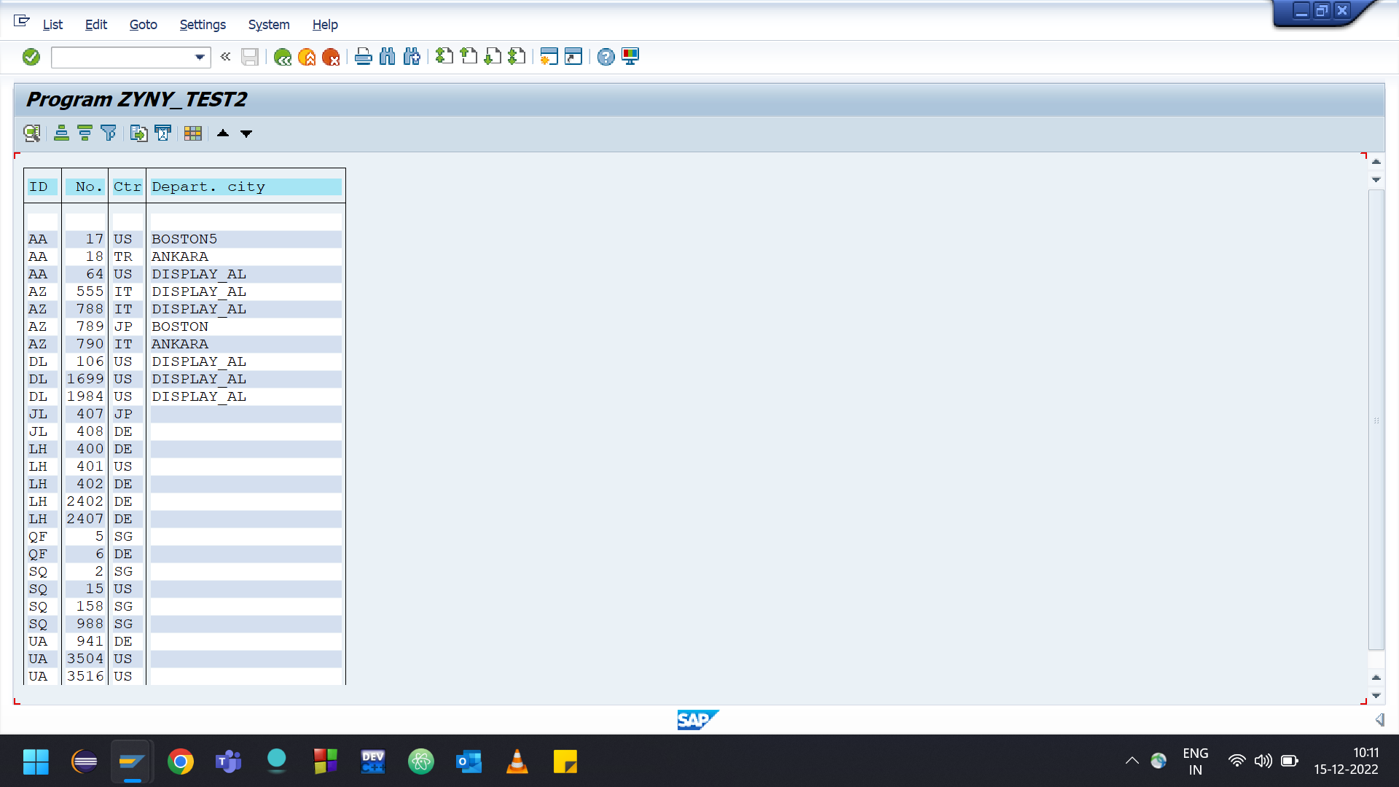

*&---------------------------------------------------------------------*  
*& Report  ZYNY_TEST2  
*&  
*&---------------------------------------------------------------------*  
*&  
*&  
*&---------------------------------------------------------------------*  
REPORT ZYNY_TEST2.  
  
TYPES : BEGIN OF ty_spfli,  "User defined internal table type  
          carrid    TYPE spfli-carrid,  
          connid    TYPE spfli-connid,  
          countryfr TYPE spfli-countryfr,  
          cityfrom  TYPE spfli-cityfrom,  
        END OF ty_spfli.  
  
DATA : it_spfli TYPE TABLE OF ty_spfli, "SPFLI internal table  
       wa_spfli TYPE ty_spfli. "work area  
  
DATA : t_fcat_spfli TYPE slis_t_fieldcat_alv. "field catalog for SPFLI table  
DATA : w_fcat_spfli LIKE LINE OF t_fcat_spfli.  
  
TYPES : BEGIN OF ty_sflight,  
          carrid TYPE sflight-carrid,  
          connid TYPE sflight-connid,  
          fldate TYPE sflight-fldate,  
          price  TYPE sflight-price,  
        END OF ty_sflight.  
  
DATA : it_sflight TYPE TABLE OF ty_sflight, "SFLIGHT internal table  
       wa_sflight TYPE ty_sflight.  
DATA : t_fcat_sflight TYPE slis_t_fieldcat_alv. "SFLIGHT field catalog  
DATA : w_fcat_sflight LIKE LINE OF t_fcat_sflight.  
  
DATA s_events TYPE slis_t_event.  
  
DATA s_layout TYPE slis_layout_alv.  
s_layout-zebra = 'X'.  
  
PARAMETERS : p_carrid TYPE spfli-carrid. "CARRID type input  
  
START-OF-SELECTION.  
  PERFORM get_data.  
  PERFORM create_fcat_spfli.  
  PERFORM create_fcat_sflight.  
  PERFORM block_list_init.  
  PERFORM block_list_append_spfli.  
  PERFORM block_list_append_sflight.  
  
 CALL FUNCTION 'REUSE_ALV_BLOCK_LIST_DISPLAY' . "display blocked list  
  
FORM get_data.  
  SELECT carrid  
         connid  
         countryfr  
         cityfrom  
         FROM spfli "get SPFLI data  
    INTO TABLE it_spfli.  
*      WHERE carrid = p_carrid.  
  IF NOT it_spfli IS INITIAL .  
    SELECT  carrid connid  
            fldate  
            price FROM sflight INTO TABLE it_sflight "get flight data  
      FOR ALL ENTRIES IN it_spfli WHERE carrid = it_spfli-carrid.  
  ENDIF.  
ENDFORM.  
  
FORM create_fcat_spfli.  
  REFRESH t_fcat_spfli.  
  w_fcat_spfli-col_pos       = '1'. "coloum position  
  w_fcat_spfli-fieldname     = 'CARRID'. "column name  
   w_fcat_spfli-ref_tabname   = 'SPFLI'. "table  
  w_fcat_spfli-ref_fieldname = 'CARRID'. "reference field, it will show descriptions automatically  
  APPEND w_fcat_spfli TO t_fcat_spfli.  
  CLEAR w_fcat_spfli.  
  
  w_fcat_spfli-col_pos       = '2'.  
  w_fcat_spfli-fieldname     = 'CONNID'.  
  w_fcat_spfli-ref_tabname   = 'SPFLI'.  
  w_fcat_spfli-ref_fieldname = 'CONNID'.  
  APPEND w_fcat_spfli TO t_fcat_spfli.  
  CLEAR w_fcat_spfli.  
  
  w_fcat_spfli-col_pos       = '3'.  
  w_fcat_spfli-fieldname     = 'COUNTRYFR'.  
  w_fcat_spfli-ref_tabname   = 'SPFLI'.  
  w_fcat_spfli-ref_fieldname = 'COUNTRYFR'.  
  APPEND w_fcat_spfli TO t_fcat_spfli.  
  CLEAR w_fcat_spfli.  
  
  w_fcat_spfli-col_pos       = '4'.  
  w_fcat_spfli-fieldname     = 'CITYFROM'.  
  w_fcat_spfli-ref_tabname   = 'SPFLI'.  
  w_fcat_spfli-ref_fieldname = 'CITYFROM'.  
  APPEND w_fcat_spfli TO t_fcat_spfli.  
  CLEAR w_fcat_spfli.  
  
ENDFORM.  
  
FORM create_fcat_sflight.  
  refresh t_fcat_sflight.  
***build fcat for SFLIGHT  
  w_fcat_sflight-col_pos       = '1'.  
  w_fcat_sflight-fieldname     = 'CARRID'.  
  w_fcat_sflight-ref_tabname   = 'SFLIGHT'.  
  w_fcat_sflight-fieldname     = 'CARRID'.  
  APPEND w_fcat_sflight TO t_fcat_sflight.  
  CLEAR w_fcat_sflight.  
  
  w_fcat_sflight-col_pos       = '2'.  
  w_fcat_sflight-fieldname     = 'CONNID'.  
  w_fcat_sflight-ref_tabname   = 'SFLIGHT'.  
  w_fcat_sflight-ref_fieldname = 'CONNID'.  
  APPEND w_fcat_sflight TO t_fcat_sflight.  
  CLEAR w_fcat_sflight.  
  
  w_fcat_sflight-col_pos       = '3'.  
  w_fcat_sflight-fieldname     = 'FLDATE'.  
  w_fcat_sflight-ref_tabname   = 'SFLIGHT'.  
  w_fcat_sflight-ref_fieldname = 'FLDATE'.  
  APPEND w_fcat_sflight TO t_fcat_sflight.  
  CLEAR w_fcat_sflight.  
  
  w_fcat_sflight-col_pos       = '3'.  
  w_fcat_sflight-fieldname     = 'PRICE'.  
  w_fcat_sflight-ref_tabname   = 'SFLIGHT'.  
  w_fcat_sflight-ref_fieldname = 'PRICE'.  
  APPEND w_fcat_sflight TO t_fcat_sflight.  
  CLEAR w_fcat_sflight.  
  
  
ENDFORM.  
  
FORM block_list_init.  
  CALL FUNCTION 'REUSE_ALV_BLOCK_LIST_INIT' "initialize Block List ALV  
    EXPORTING  
      i_callback_program = sy-repid.  
ENDFORM.  
  
FORM block_list_append_spfli.  
  
  
  
  CALL FUNCTION 'REUSE_ALV_BLOCK_LIST_APPEND' "append ALV lists  
    EXPORTING  
      is_layout   = s_layout "set layout  
      it_fieldcat = t_fcat_spfli "set field catalog  
     i_tabname   = 'IT_SPFLI' "table  
      it_events   = s_events "events  
    TABLES  
      t_outtab    = it_spfli. "out put table  
  
  IF sy-subrc <> 0.  
* Implement suitable error handling here  
  ENDIF.  
ENDFORM.  
  
FORM block_list_append_sflight.  
  CALL FUNCTION 'REUSE_ALV_BLOCK_LIST_APPEND' "append ALV lists  
    EXPORTING  
      is_layout   = s_layout "set layout  
      it_fieldcat = t_fcat_sflight "set field catalog  
      i_tabname   = 'IT_SFLIGHT' "table  
      it_events   = s_events "events  
    TABLES  
      t_outtab    = it_sflight. "out put table  
  
  IF sy-subrc <> 0.  
* Implement suitable error handling here  
  ENDIF.  
  
ENDFORM.

with sflight it will be printed below the first alv

